





**Data-Driven Warehousing:**

**Empowering Inventory Management**

**Data-Driven Warehousing : Empowering Inventory Management using Power BI**

**Introduction:**

The Inventory Management Analytics project aims to leverage Power BI to provide comprehensive insights into inventory levels, trends, and performance metrics for efficient inventory management. By integrating data from various sources such as sales, procurement, and production, this solution enables businesses to make data-driven decisions, optimize stocking levels, minimize stockouts, and maximize inventory turnover.

However, behind each successful company lies a complex web of planning, preparation, and execution. Understanding the intricacies of company’s inventories , including factors such as product type, supplier and supplier location is crucial for evaluating performance, identifying trends, and informing future endeavors. This is where the power of data analysis comes into play.

By implementing the Inventory Management Analytics solution with Power BI, organizations can transform their inventory management practices, mitigate risks, and capitalize on opportunities for sustainable growth and competitiveness in today's dynamic business environment.

**Real Time Scenarios:**

**1.Accurate Stock Monitoring and Replenishment**:

Imagine a retail store with perishable goods. Real-time tracking allows the store to monitor stock levels continuously. When a product reaches a predefined threshold, an automatic reorder is triggered. This ensures that shelves remain stocked, minimizing lost sales due to stockouts.

**2.E-Commerce Fulfillment Optimization:**

An online retailer faces fluctuating demand. With real-time inventory data, they can dynamically allocate stock across warehouses based on order volume and shipping zones. This optimization reduces delivery times and enhances customer satisfaction.

**3.Supply Chain Visibility**:

A manufacturer sources components from multiple suppliers. Real-time tracking provides visibility into supplier inventory levels. If a critical component is running low, the manufacturer can proactively engage with the supplier to prevent production delays.

4. **Just-in-Time Manufacturing**:

An automotive assembly line relies on real-time inventory data to synchronize production. Components arrive precisely when needed, minimizing storage costs and streamlining the manufacturing process.

**5.Warehouse Space Utilization**:

A logistics company manages a vast warehouse network. Real-time tracking helps optimize space utilization. By identifying underutilized areas, they can reorganize storage and maximize warehouse efficiency.

**Technical Architecture:**

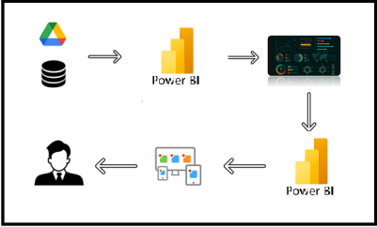

**Project Flow**

To accomplish this, we have to complete all the activities listed below,

* Data Collection
  + Collect the dataset,
  + Connect Data with Power BI
* Data Preparation
  + Prepare the Data for Visualization
* Data Visualizations
  + Visualizations
* Dashboard
  + Responsive and Design of Dashboard
* Report
* Report Creation
* Performance Testing
  + Amount of Data Rendered to DB
  + Utilization of Data Filters
  + No. of Calculation fields
  + No. of Visualizations/Graphs
* Project Demonstration & Documentation
  + Record explanation Video for project end to end solution
  + Project Documentation-Step by step project development procedure

**Milestone 1: Data Collection & Extraction from Database**

Data collection is the process of gathering and measuring information on variables of interest, in an established systematic fashion that enables one to answer stated research questions, test hypotheses, evaluate outcomes and generate insights from the data.

**Activity 1: Downloading the dataset**

Link:

<https://www.kaggle.com/datasets/arkhepacis/raw-materials?rvi=1>

**Activity 1.1: Understand the data**

Data contains all the meta information regarding the columns described in the CSV files

**Column Description of the Dataset:**

Sure, here's a description for each of the columns you provided:

1. Raw material id: This column likely contains unique identifiers (IDs) for each raw material item in the dataset. These IDs could be alphanumeric or numeric values assigned to each raw material.

2. supplier: This column likely contains the name or identifier of the supplier from which the raw material was purchased. It could be a company name, supplier code, or any other identifier that helps identify the supplier.

3. Supplier location: This column likely contains information about the location of the supplier, such as the city, state, country, or any other relevant geographic information.

4. product type: This column likely specifies the type or category of the raw material. It could indicate the material's composition, purpose, or any other relevant classification.

5. beginning quantity: This column likely represents the quantity of the raw material available at the beginning of a specified period, such as the beginning of a month, quarter, or year. The unit of measurement for this quantity should be specified elsewhere or inferred from the context.

6. ending quantity: This column likely represents the quantity of the raw material available at the end of the same specified period as the beginning quantity. Similar to the beginning quantity column, the unit of measurement for this quantity should be specified elsewhere or inferred from the context.

7. cost per unit: This column likely represents the cost per unit of the raw material. It could be the cost of one unit of measurement (e.g., cost per kilogram, cost per liter) of the raw material.

8. Cost per unit Ranges: This column might provide a range of costs per unit for the raw material instead of a single value. It could indicate the minimum and maximum costs per unit for the raw material.

9. Total Inventory Value: This column likely represents the total value of the inventory of the raw material. It could be calculated by multiplying the quantity of the raw material by its cost per unit and represents the total cost of all units of the raw material in inventory.

**Milestone 2: Data Preparation**

Preparing the data for visualization involves cleaning the data to remove irrelevant or missing data, transforming the data into a format that can be easily visualized, exploring the data to identify patterns and trends, filtering the data to focus on specific subsets of data, preparing the data for visualization software, and ensuring the data is accurate and complete.

**Activity 1: Prepare the Data for Visualization**

This process helps to make the data easily understandable and ready for creating visualizations to gain insights into the performance and efficiency. Since the data is already cleaned, we can move to visualization.

3.1: Data Loading:

<https://drive.google.com/file/d/1Fi6-xoSQsvSTKNRvNeshqJ-YVvd5z2WL/view?usp=sharing>

3.2 Data Cleaning:

Link1:

<https://drive.google.com/file/d/1JgbMuSbcSw62mvVilxYuqitMl2hGJgdH/view?usp=sharing>

Link2:

<https://drive.google.com/file/d/1tQiAS8bTAgZ_HDc_OopIyBjhrVdyRvuG/view?usp=sharing>

3.3 Data modelling:

<https://drive.google.com/file/d/1n3yfk0UKlrOZjYtwhETdu7u2CypDPegM/view?usp=sharing>

**Milestone 3: Data Visualization**

Data visualization is the process of creating graphical representations of data to help people understand and explore the information. The goal of data visualization is to make complex data sets more accessible, intuitive, and easier to interpret. By using visual elements such as charts, graphs, and maps, data visualizations can help people quickly identify patterns, trends, and outliers in the data.

**Activity 1.1: supplier location wise Total inventory value using map**

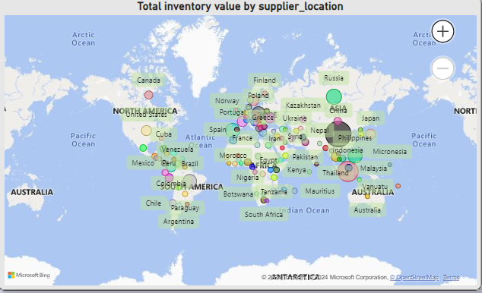

**Activity 1.2: comparing avg inventory from 2010 and 2021**

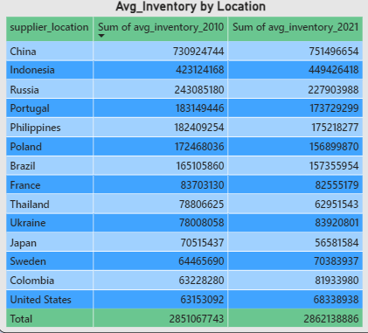

**Activity 1.3: cost per unit by product type using funnel chart**

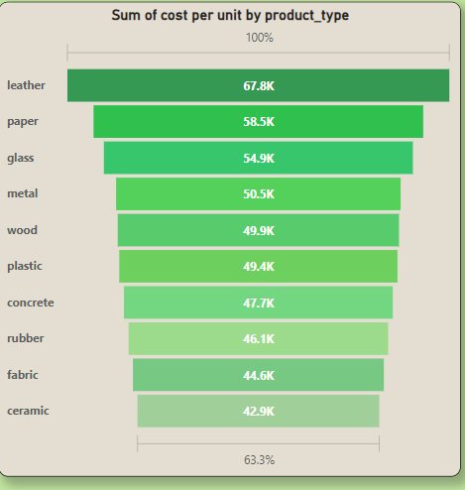

**Activity 1.4: Location wise cost per unit ranges count using donut chart.**

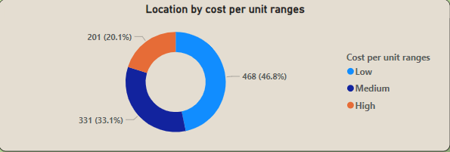

**Activity 1.5: KPI’s using cards**

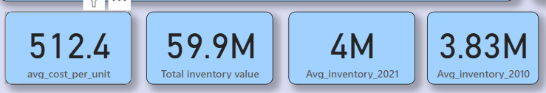

**Activity 1.6: supplier wise sum of total inventory value using stacked bar chart**

**:** 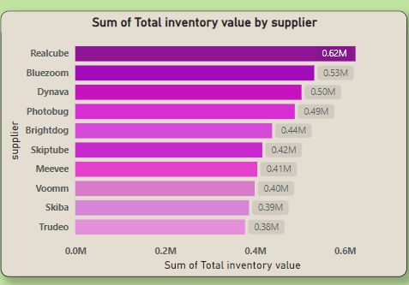

**Activity 1.7: year vs Avg inventory value using line chart**

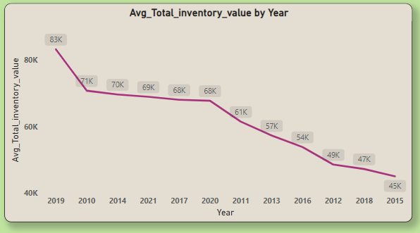

**Activity 1.8: comparing inventory values vs product type from 2010 and 2021**

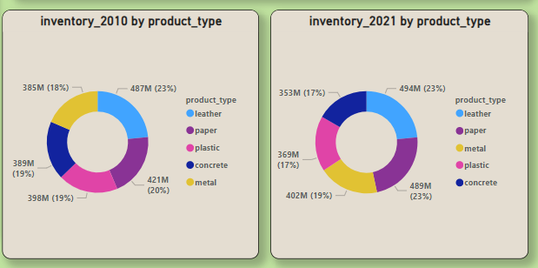

**NOTE:** Video Explanations for the above Visualizations are in Dashboard and Report sections.

**Milestone 4: Dashboard**

A dashboard is a graphical user interface (GUI) that displays information and data in an organized, easy-to-read format. Dashboards are often used to provide real-time monitoring and analysis of data and are typically designed for a specific purpose or use case. Dashboards can be used in a variety of settings, such as business, finance, manufacturing, healthcare, and many other industries. They can be used to track key performance indicators (KPIs), monitor performance metrics, and display data in the form of charts, graphs, and tables.

**Activity 1- Responsive and Design of Dashboard**

**Explanation video link:**

[**https://drive.google.com/file/d/1Rmz4Fts6s7d91e91H33KhOOkI1O-UIA8/view?usp=sharing**](https://drive.google.com/file/d/1Rmz4Fts6s7d91e91H33KhOOkI1O-UIA8/view?usp=sharing)

**Dashboard:**

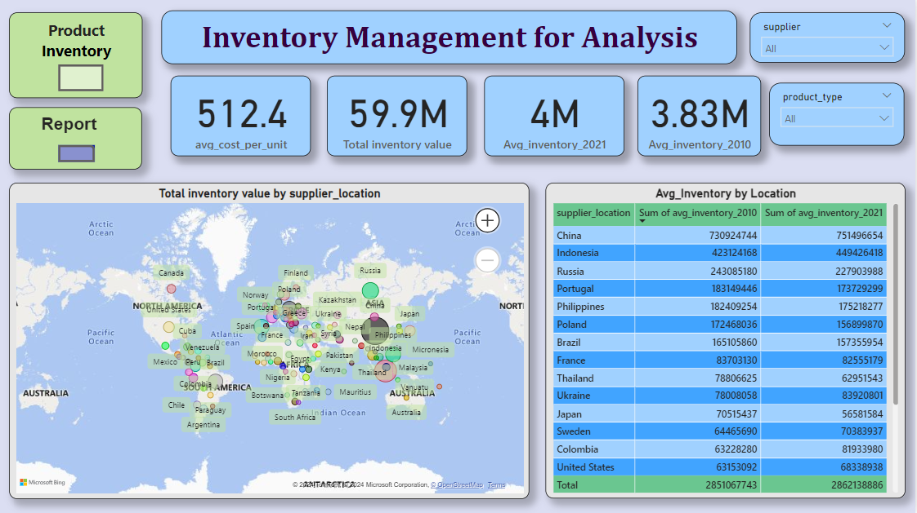

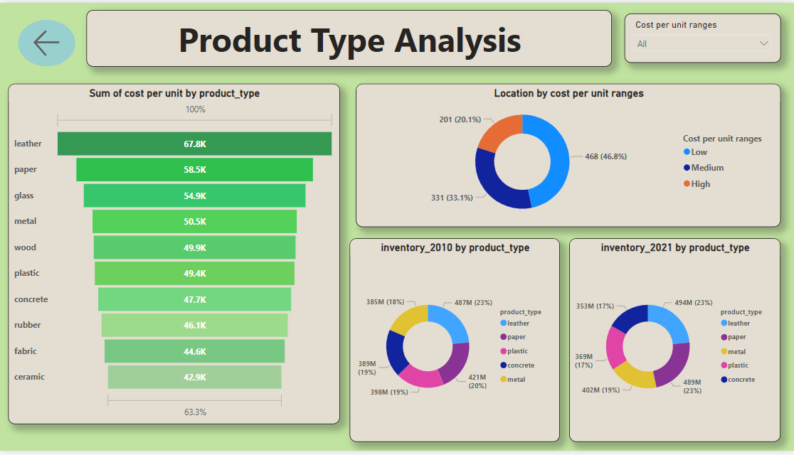

**Milestone 5: Report**

A report is a comprehensive document that provides a detailed and structured account of data analysis, findings, and insights. It is typically used for in-depth analysis, documentation, and communication of results. Reports are suitable for a diverse audience, including decision-makers, analysts, and stakeholders who need a comprehensive understanding of the data.

**Activity 1: Design of Report**

Designing a report in Power BI involves connecting to data sources, creating visualizations like charts and graphs, customizing their appearance and interactivity, organizing them logically on the canvas, formatting elements for consistency and clarity, and optionally creating dashboards for a summarized view. Throughout the process, it's essential to consider the audience's needs and ensure the report effectively communicates insights from the data. Finally, iterate based on feedback to continually improve the report's design and usefulness.

**Explanation video link:**

<https://drive.google.com/file/d/1k0NmXvgOy6Gnpd4HeAy01clYhyYERKis/view?usp=sharing>

**Report:**

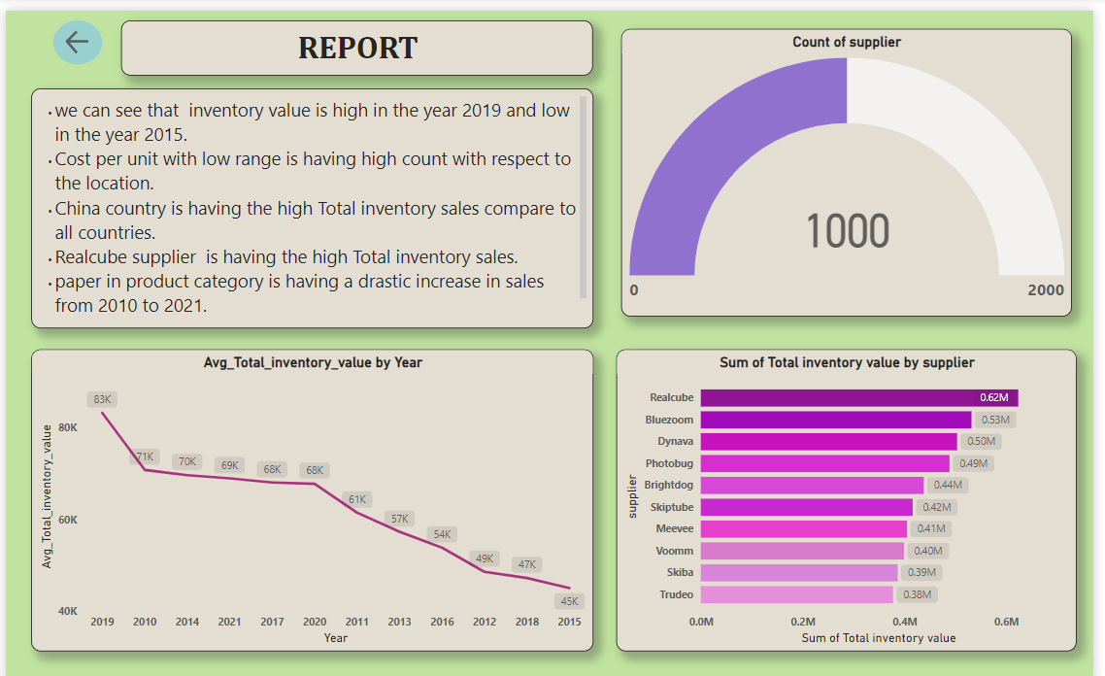

**Milestone 6: Performance Testing**

Performance testing is a crucial aspect of software development aimed at evaluating the speed, responsiveness, stability, and scalability of an application under various workload conditions. It involves simulating real-world usage scenarios to assess how the system behaves and performs under stress, peak loads, or normal conditions.

**Activity 1: Amount of Data Loaded**

"Amount of Data Loaded" refers to the quantity or volume of data that has been imported, retrieved, or loaded into a system, software application, database, or any other data storage or processing environment. It's a measure of how much data has been successfully processed and made available for analysis, manipulation, or use within the system.

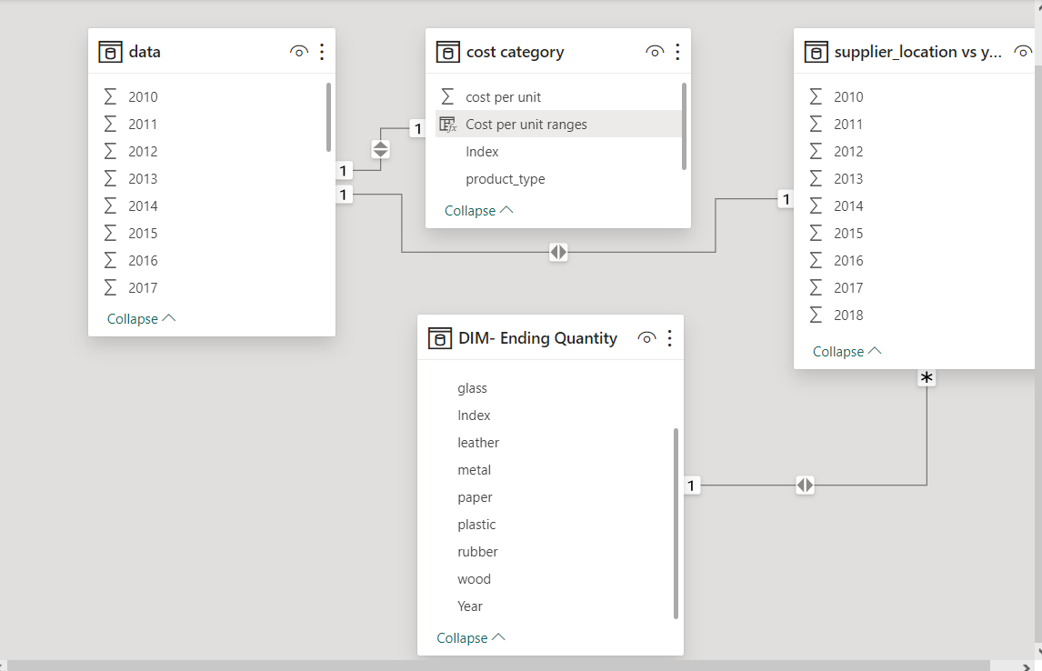

**Activity 2: Utilization of Filters**

"Utilization of Filters" refers to the application or use of filters within a system, software application, or data processing pipeline to selectively extract, manipulate, or analyze data based on specified criteria or conditions.

**Activity 2.1: Selected medium cost per unit range as filter**

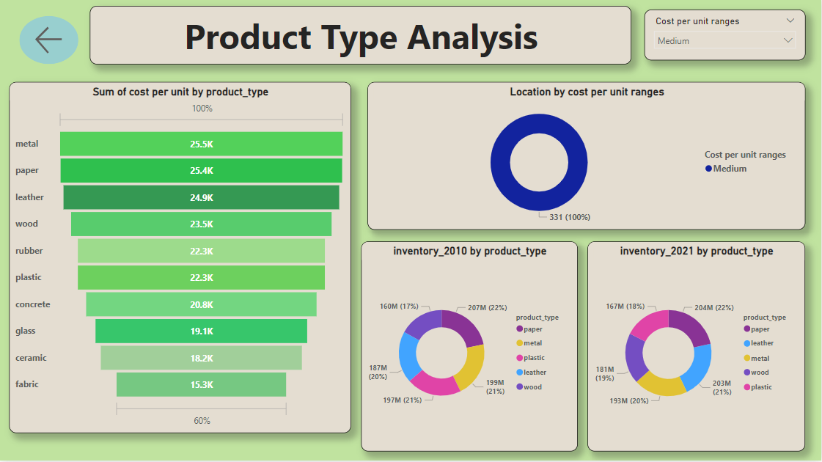

**Activity 3: No of Calculation Fields**

* Avg cost per unit
* Total inventory value
* Avg quantity columns for 2010 and 2021
* Cost per unit ranges .

**Activity 3.1: Measure**

In Power BI, a measure is a calculation based on data in your dataset. Measures are created using DAX (Data Analysis Expressions), a formula language that allows you to perform calculations, create aggregations, and define business logic. Measures can perform various functions such as summing values, calculating averages, counting occurrences, or performing complex calculations based on conditions.

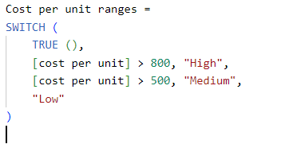

**Activity 4: No of Visualizations/ Graphs**

1. supplier location wise Total inventory value.
2. comparing avg inventory from 2010 and 2021.
3. cost per unit by product type.
4. Location wise cost per unit ranges count .
5. supplier wise sum of total inventory value.
6. year vs Avg inventory value.
7. comparing inventory values vs product type from 2010 and 2021.

**Milestone 7: Project Demonstration & Documentation**

Below mentioned deliverables to be submitted along with other deliverables

**Activity 1: - Record explanation Video for the project's end-to-end solution**

**Activity 2: - Project Documentation-Step by step project development procedure**

Create document as per the template provided